**PRECIPITATION REACTIONS**

**DEFINITIONs**

**Precipitation:** In a solution, it means; that, “soluble” reactants (ag-ab) should be aggregated, condensed, and fall, thus; separated from a solution.

**Precipitin**: An antibody (soluble) that interacts with an antigen (soluble) to cause precipitate.

**Precipitinogen**: An antigen (soluble) that induces the formation of a specific precipitin (soluble antibody).

**Lattice**: A three-dimensional grid (network).

Precipitation will develop, when the antigens (the antigens must have at least two epitopes per molecule) are cross linked and forms a lattice. For the lattice to be formed, the bivalent antibody will bind to epitopes on two different antigens. A second ab molecule combines with the second epitope on one of the antigen molecules and a third epitope on another antigen molecule, so that the complex is formed.

When repeated so many times, the complex continues to grow “until” it is sufficiently large to become insoluble and precipitate. Because the antigen is soluble, a large “number” of molecules are required for lattice formation.

When the ag concentration is very low and that of the ab is relatively superabundant (zone of ab excess), formation of “small” complexes occurs. If the mixture [reactants (ag-ab)] are centrifuged, residual abs will remain in the supernatant. This area (supernatant) containing excess antibodies is called **PROZONE**.

A more antigen is added, large aggregates form, when there is neither antigen nor antibody in the supernatant, the situation is called EQUIVALENCE ZONE . This where the maximal precipitation occurs.

With increasing the amounts of ag , the lattice size becomes too small to precipitate. This situation is called the POSTZONE (zone of ag excess). Instead of reaching the plateau, the curve comes back down to zero.



**Lattice formation**

**General information about the precipitation reactions.**

Precipitation reaction can occurs using polyclonal abs or mixture of monoclonal antibodies. If the antigen is monovalent or a single monoclonal ab is used, no lattice will form. Precipitation reactions may require hours or days to become visible, depending on the type of precipitation reaction.

In general, precipitation techniques are not as sensitive as other techniques because a “sufficient number” of antigen and antibody molecules “must” be “cross linked” in order to see the precipitate.

**Precipitation Reactions in Gel**

Various systems are available in which precipitation tests are performed in semisolid media such as agar or agarose. Agar has been found to interfere with the migration of charged particles and has been largely replaced by agarose. Agarose is a transparent, colorless, neutral gel. In the clinical laboratory several applications of the precipitation reaction are used. These methods include:

* Immunodiffusion
* Electroimmunodiffusion

**Immunodiffusion**: These are of two types: double and radial immuodiffusion.

**I. Double immunodiffusion (Ouchterlony method)**

This technique also referred to as the Ouchterlony method, may be used to determine the relationship between antigen and antibodies.

**Principle**: Antibody dilutions and specific soluble antigens are placed in adjacent wells. If the well size and shape, distance between wells, temperature, and incubation time are optimal, these solutions diffuse out, bind to each other, cross-link, and form a visible precipitate at the point of equivalence between the wells the precipitation bands will be compared with a standard antigen.

The location of the band depends on the concentration and rate of diffusion of antigen and antibody. In a condition of antibody excess, the band will be located nearer the antigen well. If two antigens are present in the solution that can be recognized by the antibody, two precipitin bands form independently as the following:

**Identity**

An identity reaction is indicated when the precipitin band forms a single smooth area. This precipitin is formed between the antibody and the two test antigens fuses (figure 1A), indicating that the antibody is precipitating identical antigen specificities in each preparation.

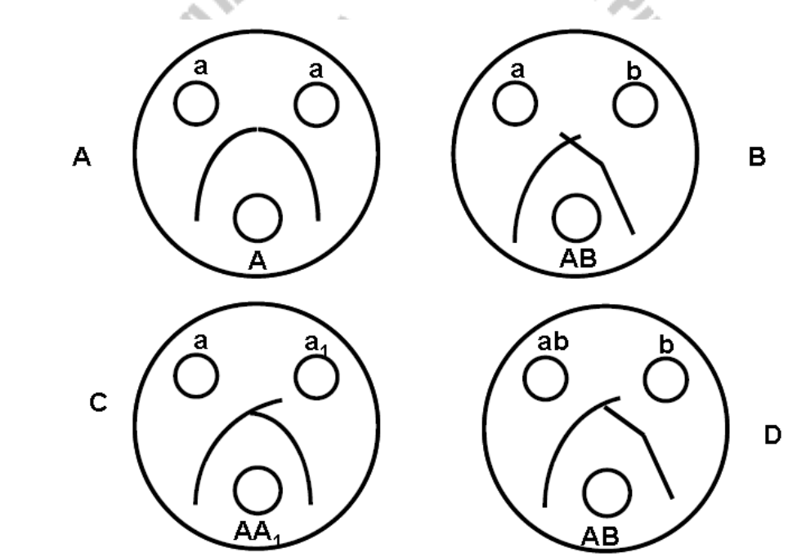

**Figure 1** Precipitation pattern of Ouchterlony type of immunodiffusion.

**Nonidentity**

A non-identity pattern (Fig 1B) is expressed when the precipitation line cross each other. They cross because the sample contains no antigenic determinants in common.

**Partial Identity**

In a partial identity pattern (Fig 1C, D); the precipitation lines fuse with spur formation. This fuser indicated that the antigen are non-identical but possess common determinants.

**II. Radial immunodiffusion (Mancini)**

In radial immunodiffusion antibody is incorporated into the agar gel as it is poured and different dilutions of the antigen are placed in holes punched into the agar. As the antigen diffuses into the gel it reacts with the antibody and when the equivalence point is reached a ring of precipitation is formed as illustrated in Figure 2.



**Figure 2**

The diameter of the ring is proportional to the concentration of antigen since the amount of antibody is constant. Thus, this is a quantitative test. If more than one ring appears in the test, more than one antigen/antibody reaction has occurred. This could be due to a mixture of antigens or antibodies. This test is commonly used in the clinical laboratory for the determination of immunoglobulin levels in patient samples.

**Eletroimmuno diffusion (EID)**

EID is a variation of the double immunodiffusion reaction in a support medium such as agarose through the use of an electric current that enhances the mobility of reactants and increase their movement towards each other.

Antibody is placed in the well favoring its migration in the direction of the cathode; antigens that tend to be more negatively charged and placed in the well that favors migration of the anode. Precipitin bands form at a point of equivalence in a shorter periods of time.

**Immunoelectrophoresis**

In immunoelectrophoresis a complex mixture of antigens is placed in a well punched out of an agar gel and the antigens are electrophoresed so that the antigen is separated according to their charge. After electrophoresis a trough is cut in the gel and antibodies are added. As the antibodies diffuse into the agar, precipitin lines are produced in the equivalence zone when an Ag/Ab reaction occurs as illustrated in Figure 3.



**Figure 3**

This test is used for the qualitative analysis of complex mixtures of antigens, although a crude measure of quantity (thickness of the line) can be obtained. This test is commonly used for the analysis of components in a patient' serum. Serum is placed in the well and antibody to whole serum in the trough. By comparisons to normal serum one can determine whether there are deficiencies on one or more serum components or whether there is an overabundance of some serum component (thickness of the line). This test can also be used to evaluate purity of isolated serum proteins.

**Counter Current immunoelectrophoresis (CIE)** is a variation of the classic precipitin procedure; it adds an electrical current to help antigens and antibodies move towards each other more quickly than in simple diffusion.

In this test the antigen and antibody are placed in wells punched out of an agar gel and the antigen and antibody are electrophoresed into each other where they form a precipitation line as illustrated in Figure 4.

This test only works if conditions can be found where the antigen and antibody have opposite charges. This test is primarily qualitative, although from the thickness of the band you can get some measure of quantity. Its major advantage is its speed.



**Figure 4**

**ROCKET TECHNIQUE**

Another electrophoretic precipitation technique, used primarily in research and coagulation laboratories, is the rocket, or Laurell technique. This technique is used to quantitate antigens other than immunoglobulins. Antiserum is incorporated into the gel. The unknwon antigen is placed in the well and electrophoresed. As the antigen migrates through the gel, it combines with antibody. Precipitation occurs along the lateral boundaries and resembles a rocket (Figure 14). The total distance of antigen migration and precipitation is directly proportional to the antigen concentration.



**Rocket Electrophoresis**